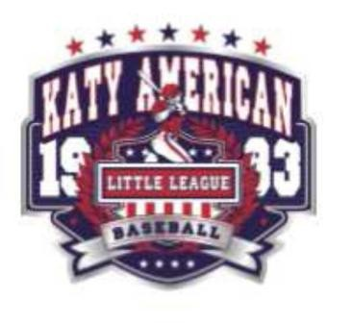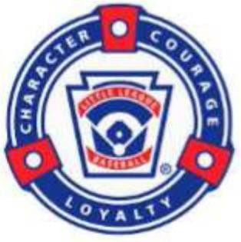
Katy American Little League
Sponsorship Form – Spring 2026

Sponsorship Levels

Grand Slam - $5000 and Up (fill out attached)
Banner on the Fence for the YEAR
8x10 Sponsor Plaque for your place of business
Top Listing on Sponsorship Banner on side of Concession Stand
Ad on Home Page, & Sponsorship Page on KatyAmerican.org Website

Homerun - $2500 (fill out attached)
Banner on the Fence for the SEASON
8x10 Sponsor Plaque for your place of business
Premium Listing on Sponsorship Banner on side of Concession Stand
Ad on Sponsorship Page on KatyAmerican.org Website

Triple - $1000 (fill out attached)
Banner on the Fence for the SEASON
8x10 Sponsor Plaque for your place of business
Listing on Sponsorship Banner on side of Concession Stand
Business name on Sponsorship Page on KatyAmerican.org Website

Double - $750
8x10 Sponsor Plaque for your place of business Pennant Banner on fence of team dugout
Listing on Sponsorship Banner on side of Concession Stand
Business name on Sponsorship Page on KatyAmerican.org Website

Single - $500 (team minimum)
8x10 Sponsor Plaque for your place of business
Pennant Banner on fence of team dugout
Ad on Sponsorship Page on KatyAmerican.org Website

Fill out this form completely and mail it along with sponsorship check to:
Katy American Little League
Attn: Bryan Sills
22011 Joshua Kendell Lane
Katy, TX 77449
*Sponsor’s Name: _____________________________________________________
Sponsor’s Website: ____________________________________________________
Business Address: _____________________________________________________
Business Phone: ______________________________________________________
*Division: ______________________________________
*Coach Name: _________________________________
*Team Name: _________________________________________________________
(*Required field so your sponsorship is applied to the correct team in each division)
(circle one) Sponsorship Level: $500(minimum), $750, $1000, $2500, $5000, Other $
Katy American Little League Spring 2026
(For Triple, Home Run, and Grand Slam Levels only)

Please fill out the below form completely: (For Triple, Home Run, and Grand Slam Levels only)

Sponsor/Business Name:
Phone Number:
Contacts:
Website Address (if listed on banner):
Team Name:
Division:
Coach Name:

*Please attach preferred logo to be printed on the sponsorship banner

